Wood Working Tool Identification
Question 1.  Identify the name of the tool pictured from the answer choices below. Click on picture to enlarge. |  | 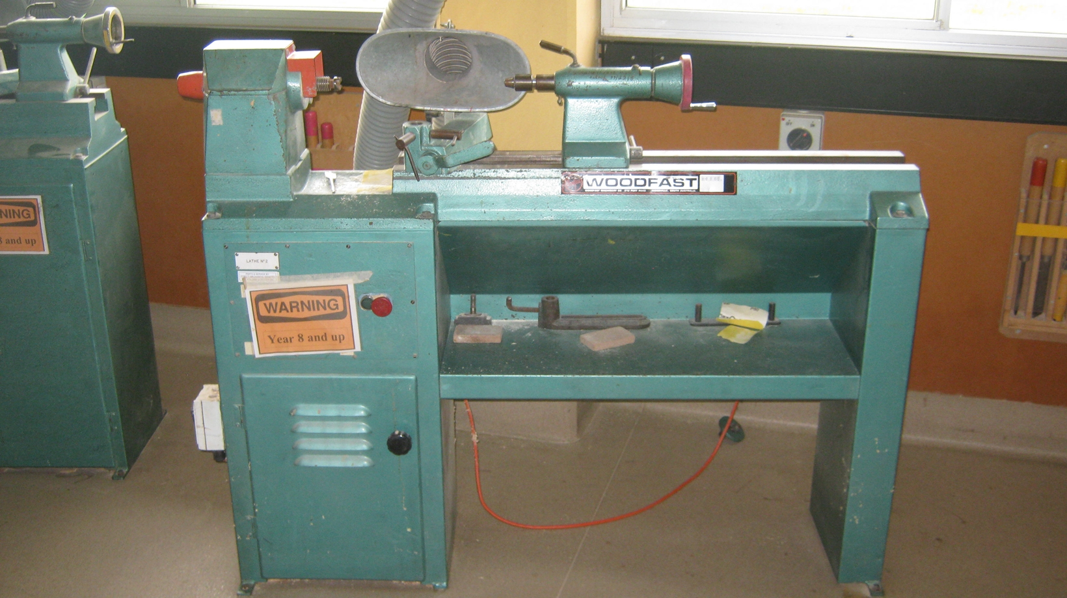
( ) | Wood lathe
( ) | Wood Grinder
( ) | Jet Machine
( ) | Wood Spinner
Question 2.  Identify the name of the tool pictured from the answer choices below. Click on picture to enlarge. |  |  | 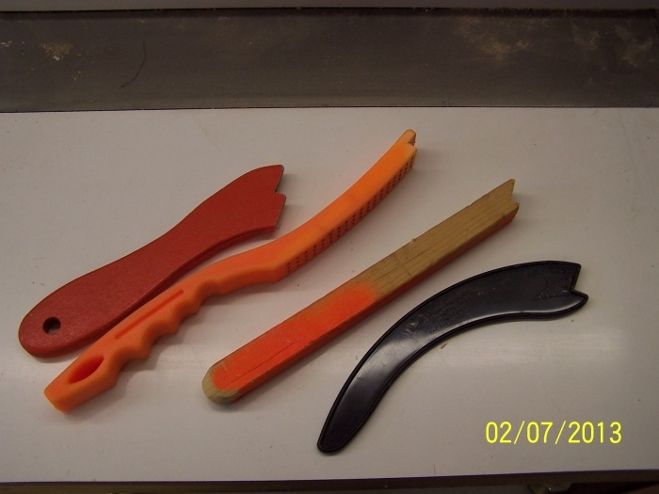
[ ] | Push Sticks
[ ] | Screw Drivers
[ ] | Ice Cream Scoops  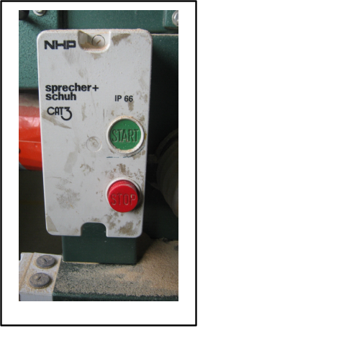
[ ] | Boomerangs

Question 3.
Which button will stop the machine?

Question 4.  Identify the name of the tool pictured from the answer choices below. |  | 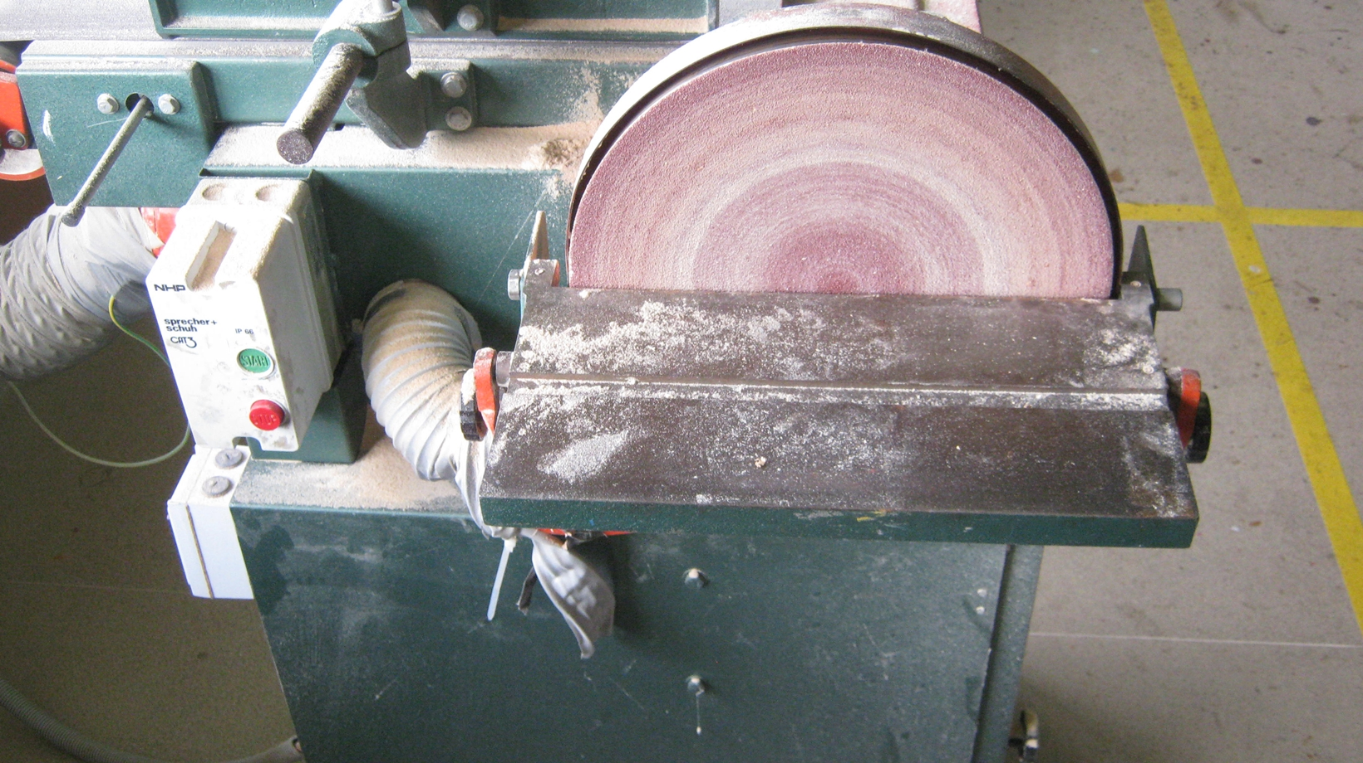
( ) | Disc sander
( ) | Orbital Sander
( ) | Round Sander
( ) | Belt Sander

Question 5.  Identify the name of the tool pictured from the answer choices below. |  | 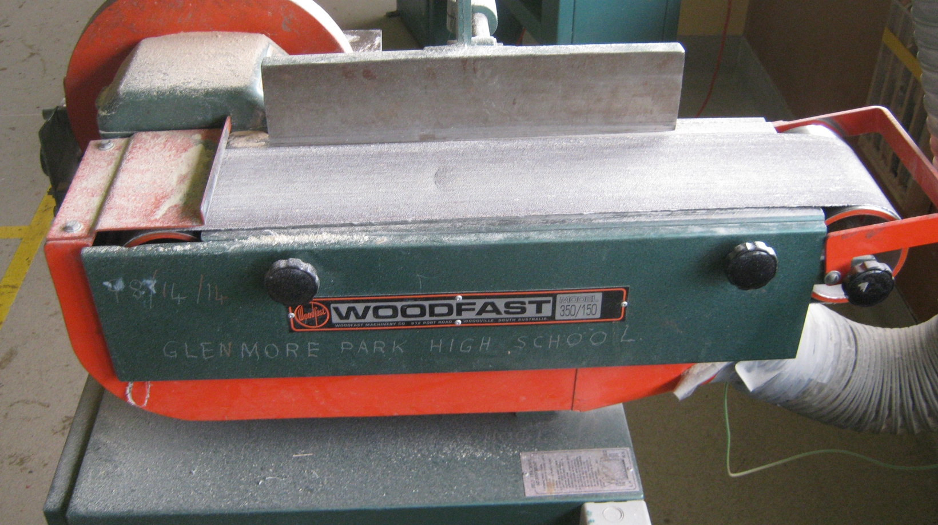
( ) | Belt Sander / Linisher
( ) | Disc Sander
( ) | Orbital Sander
( ) | Round Sander
Question 6.  Identify the name of the tool pictured from the answer choices below. Click on picture to enlarge. |  |  |  |  | 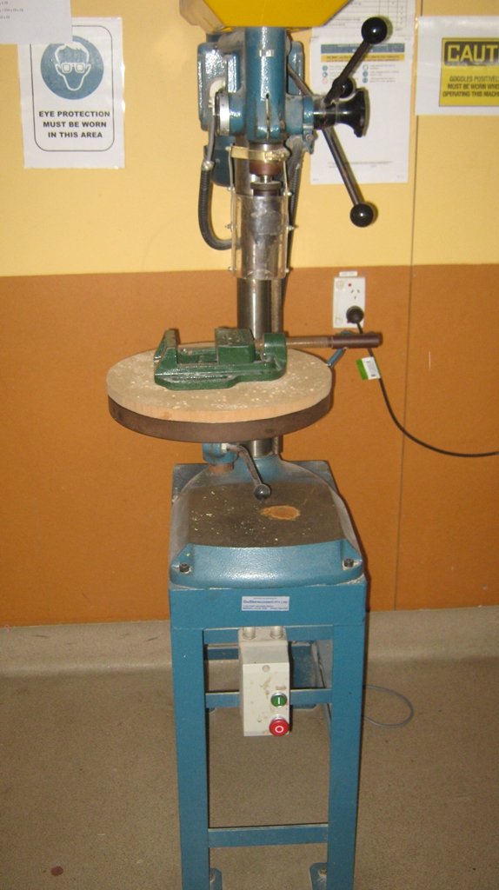
( ) | Drill Press / Pedestal Drill
( ) | Standing Drill
( ) | Hand Drill
( ) | Mortise Drill
Question 7.  Identify the name of the tool pictured from the answer choice below. |  |  | 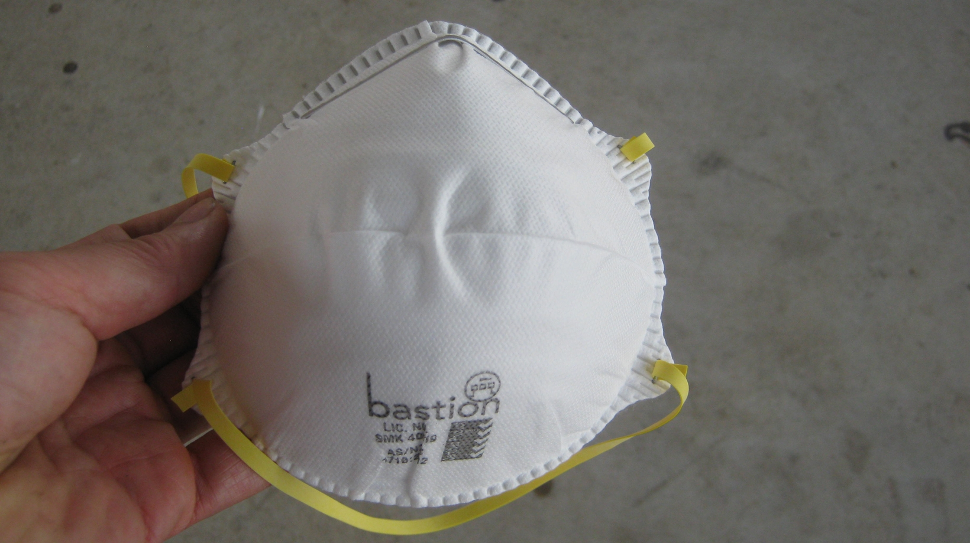
( ) | Disposable Paper Dust Mask
( ) | Cleaning cloth
( ) | Cotton Waste
( ) | Marsh mellow

Question 8.
Identify the name of the tool pictured from the answer choices below. Click on picture to enlarge.
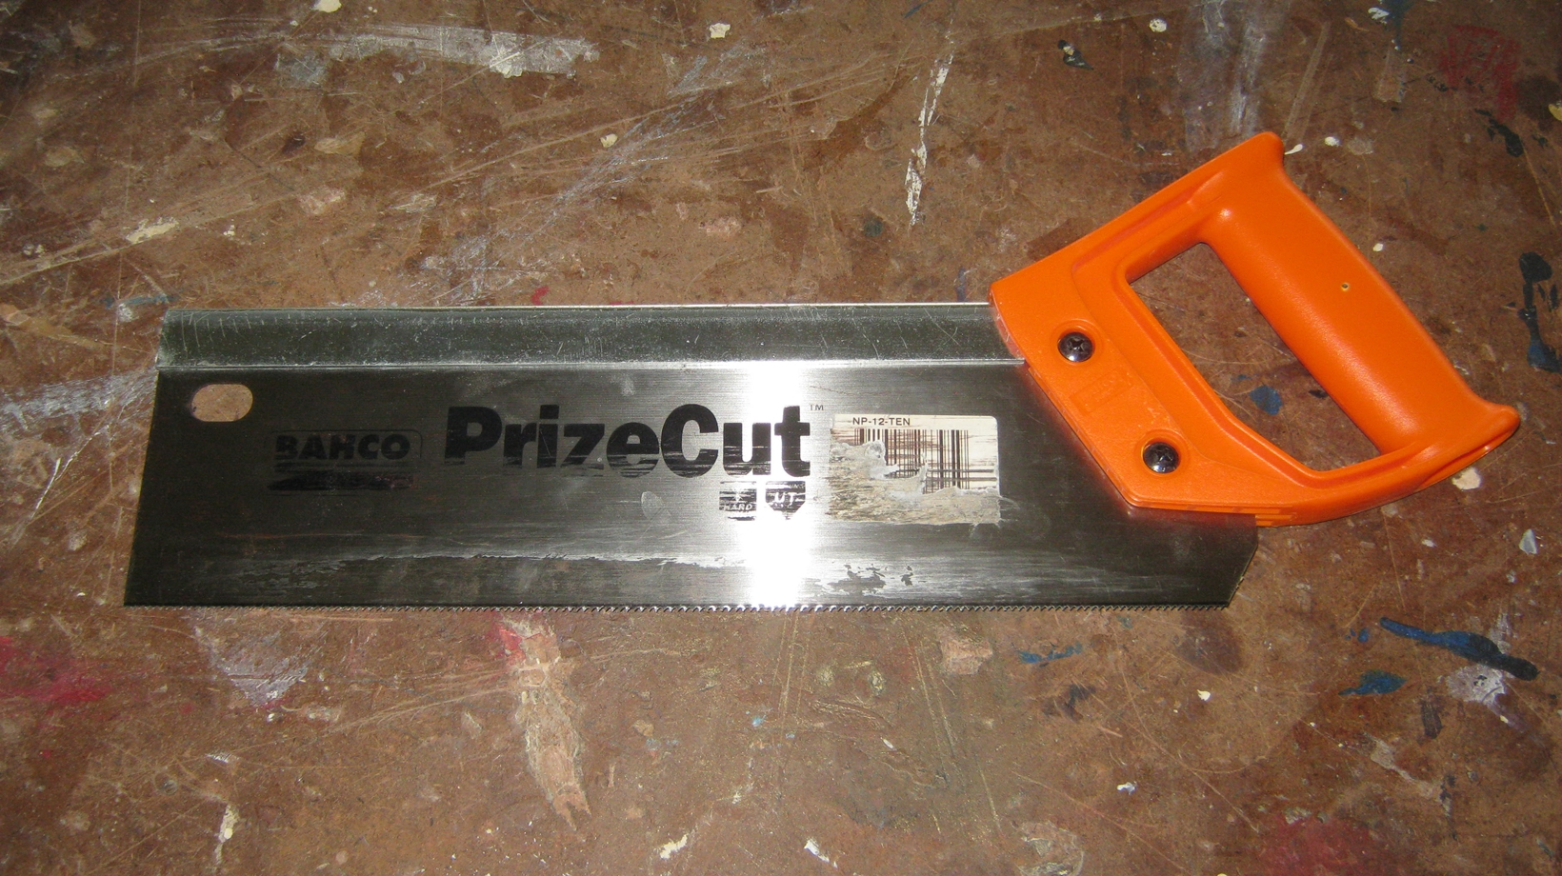
( ) | Tenon Saw
( ) | Drop Saw
( ) | Scroll Saw
( ) | Circular Saw

Question 9.
Identify the name of the tool pictured from the answer choices below. Click on picture to enlarge.
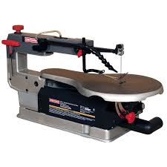
( ) | Scroll Saw
( ) | Hand Drill
( ) | Puzzle cutter
( ) | Standing Drill
Question 10.  Identify the name of the tool pictured from the answer choices below. |  | 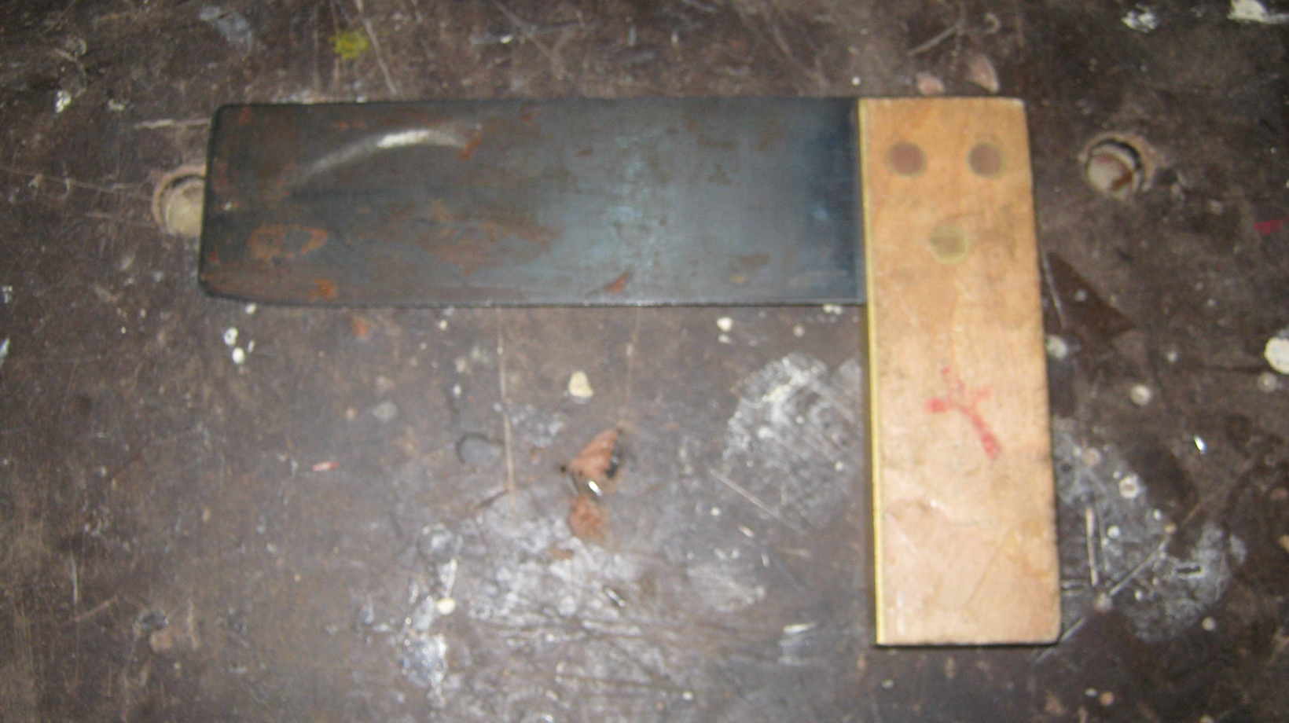
( ) | Ruler
( ) | Level
( ) | Try Square
( ) | Right angle
Question 11.  Identify the name of the tool pictured from the answer choices below. |  | 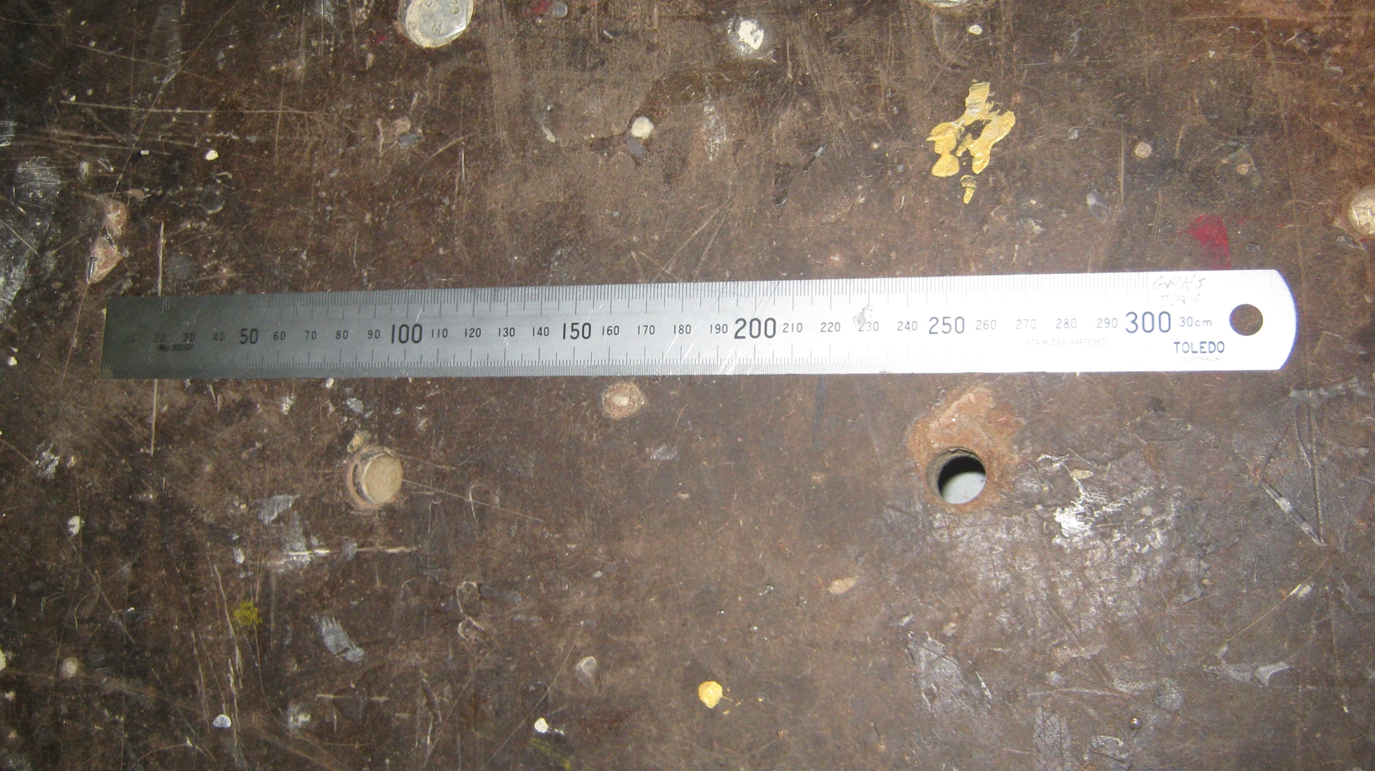
( ) | Engineers Rule
( ) | Set Square
( ) | Ruler
Question 12.  Identify the name of the tool pictured from the answer choices below. |  | 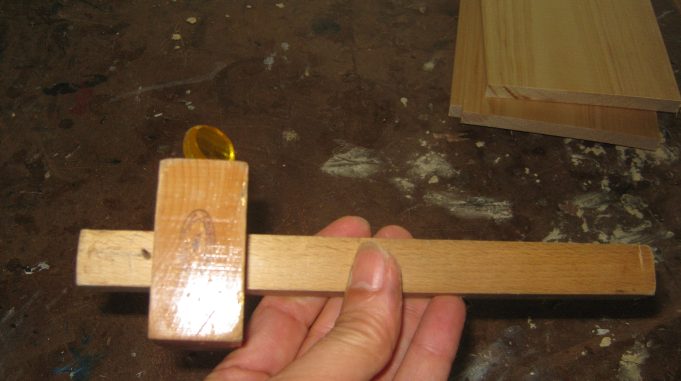
( ) | Marking gauge
( ) | Wood stop
( ) | Clipper gauge
( ) | Mortise gauge

Question 13.
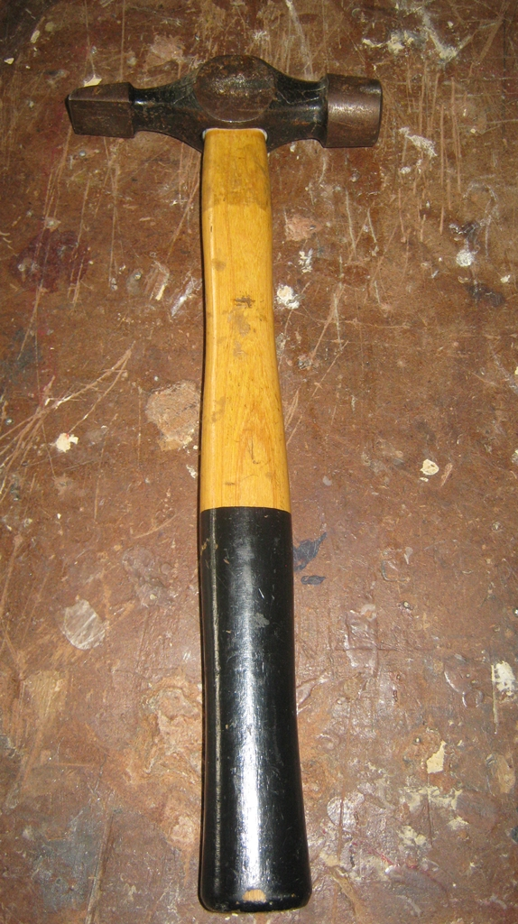
Identify the name of the tool pictured from the answer choices below.
( ) | Warrington Hammer
( ) | Claw Hammer
( ) | Tin Smith's Hammer
( ) | Rock Hammer
Question 14.  Identify the name of the tool pictured from the answer choices below. |  | 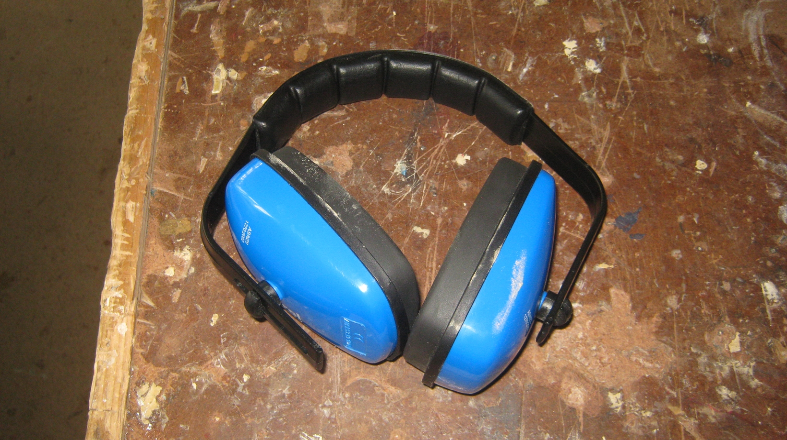
[ ] | Ear Muffs
[ ] | Ear Plugs
[ ] | Head Phones
[ ] | Waterpolo Ear Protection

Question 15.
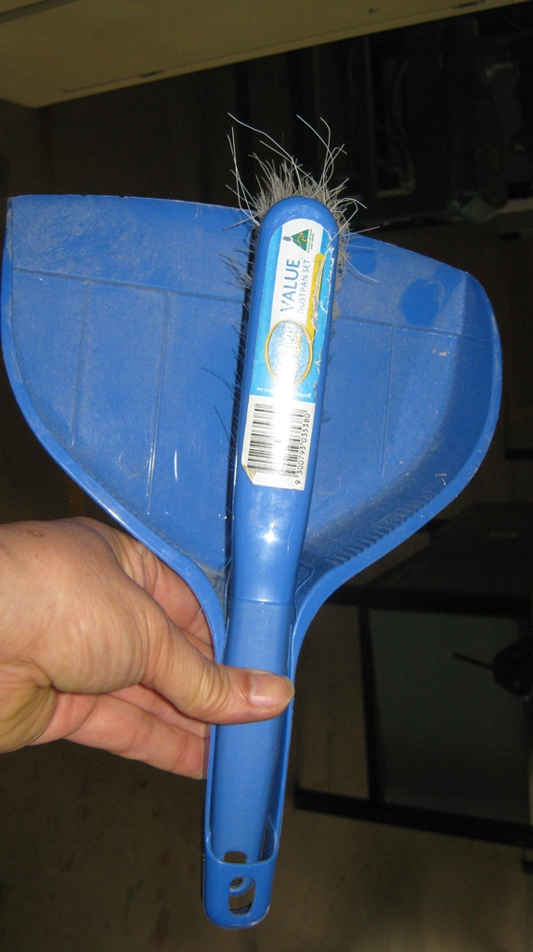
Identify the name of the tool pictured from the answer choices below.
( ) | Bannister Brush / Dustpan
( ) | Kitty litter scoop.
( ) | Pie Pan
( ) | Cleaner

Question 16.
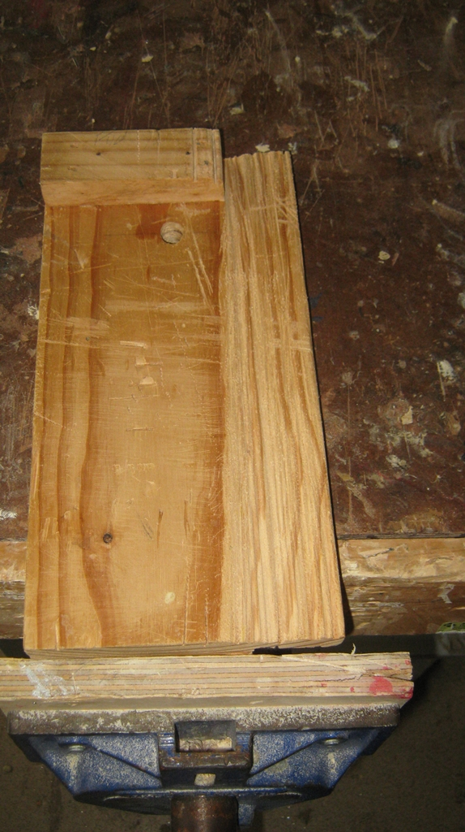
Identify the name of the tool pictured from the answer choices below. enlarge.
( ) | Bench Hook
( ) | Vice Handle
( ) | Brook's Brace
( ) | Woodwork Vice

Question 17.
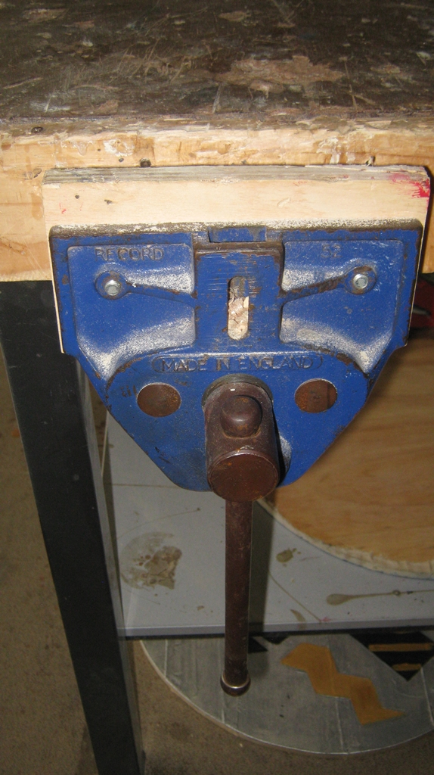
Identify the name of the tool pictured from the answer choices below.
( ) | Woodworking Vice
( ) | Metalwork Vice
( ) | Vice Crank
( ) | Emergency Siren

Question 18.
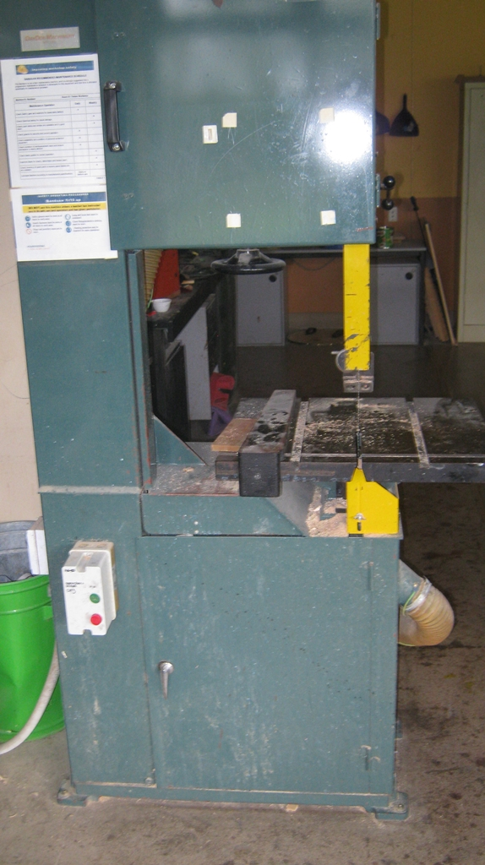
Identify the name of the tool pictured from the answer choices below.
( ) | Band Saw
( ) | Tenon Saw
( ) | Drop Saw
( ) | Electric Saw

Question 19.
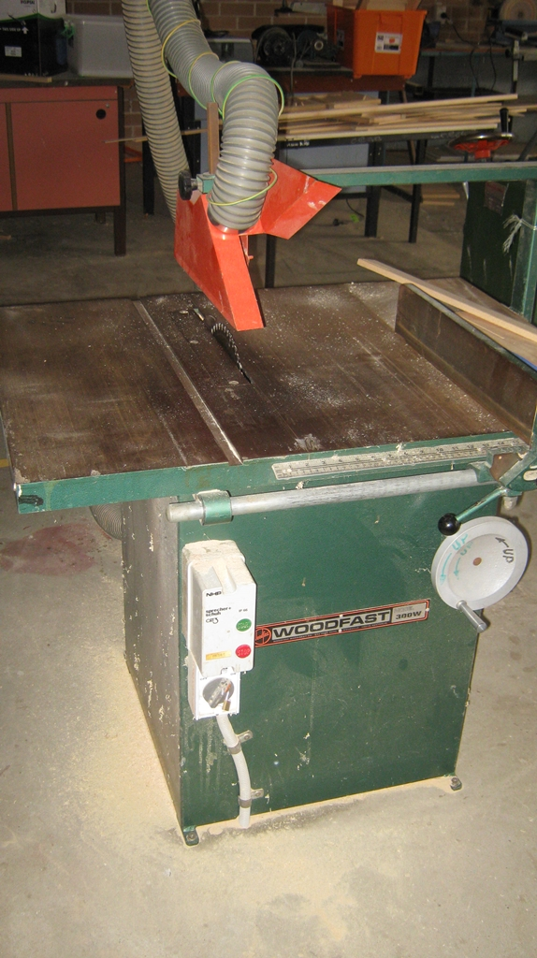
Identify the name of the tool pictured from the answer choices below.
( ) | Table Saw
( ) | Band Saw
( ) | Drop Saw
( ) | Reciprocating Saw

Question 20.
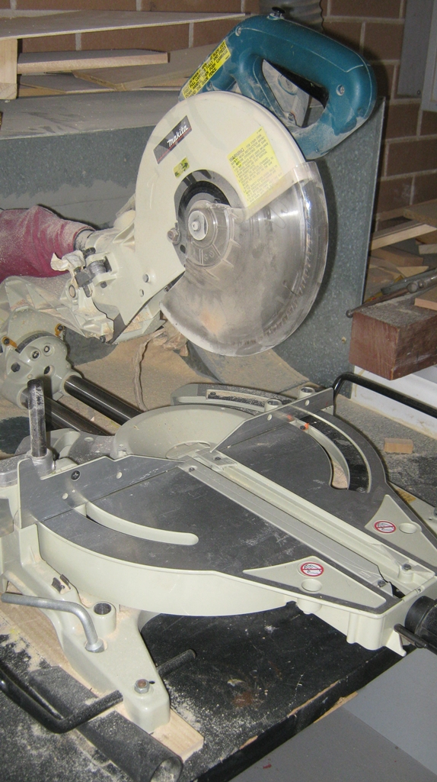
Identify the name of the tool pictured from the answer choices below.
( ) | Drop Saw / Radial Arm Saw
( ) | Table Saw
( ) | Band Saw
( ) | Tenon Saw

Question 21.
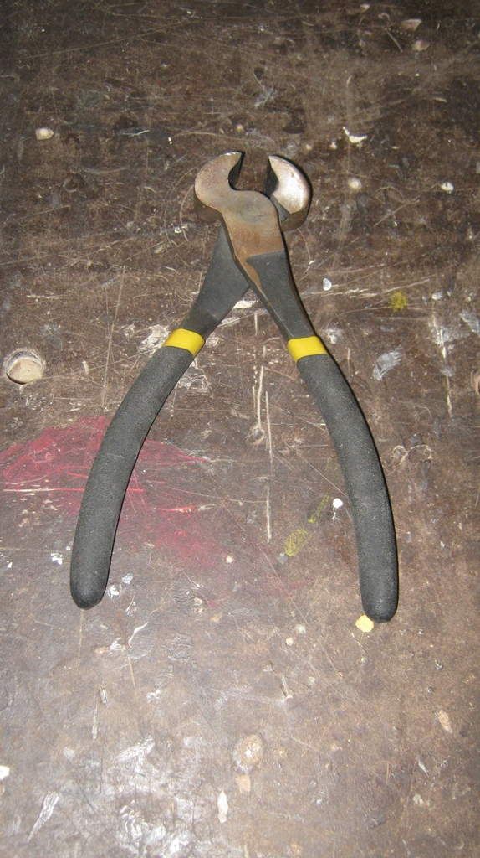
Identify the name of the tool pictured from the answer choices below.
( ) | Pincers
( ) | Nippers
( ) | Pliers
( ) | Nail Puller

Question 22.
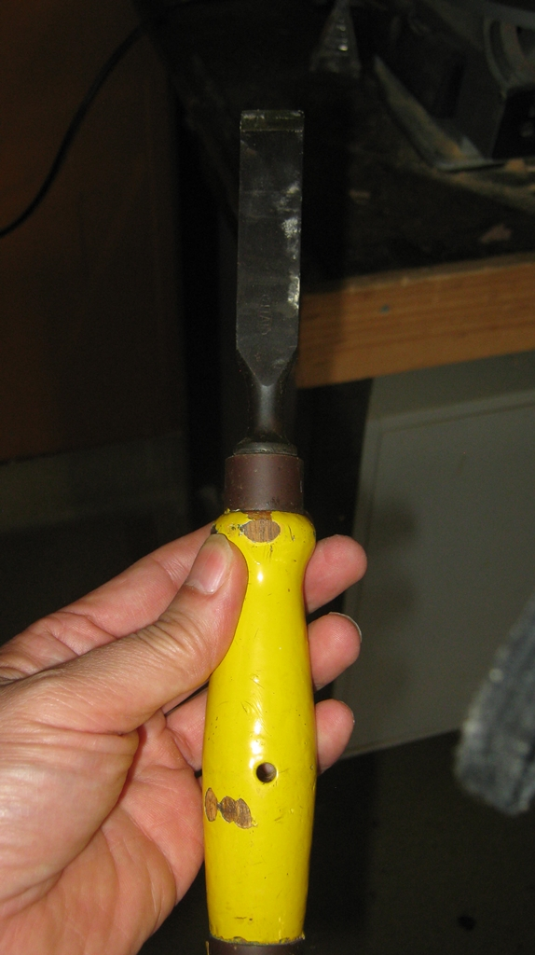
Identify the name of the tool pictured from the answer choices below.
( ) | Chisel
( ) | Screwdriver
( ) | Potato peeler
( ) | Pencil

